Bank Management – Case Study

Various SpringBoot dependencies are injected in pom.xml to perform spring boot functions

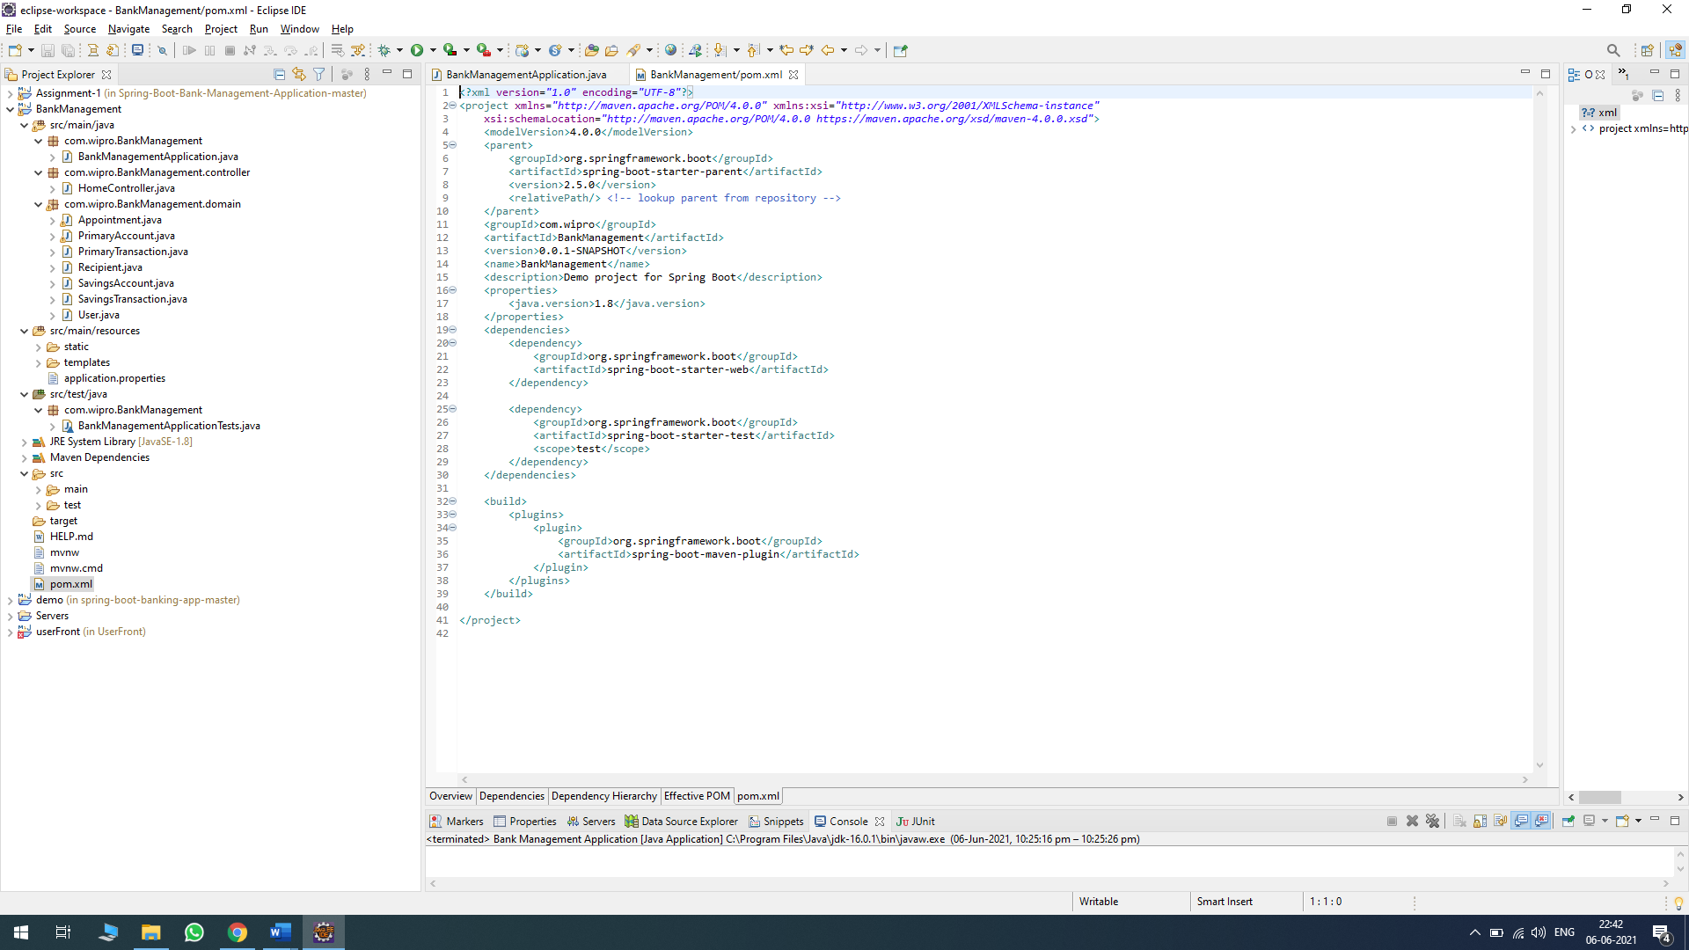

BankManagementAppilcation main class is created to initialize @SpringBootApplication

Annotation.

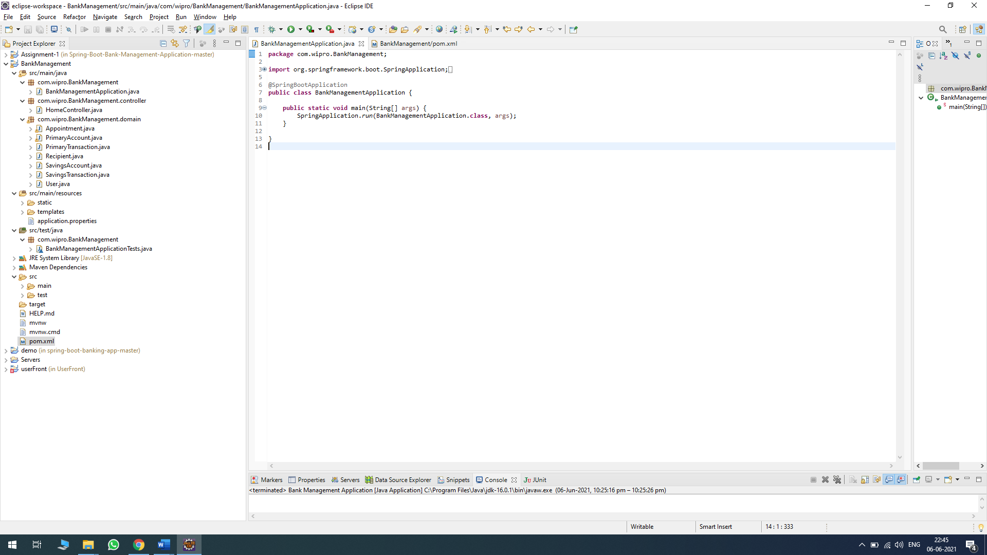

HomeController is used to get the page URL <http://localhost:8080/index> to get the login page.

The URL is mapped using @RequestMapping Annotation

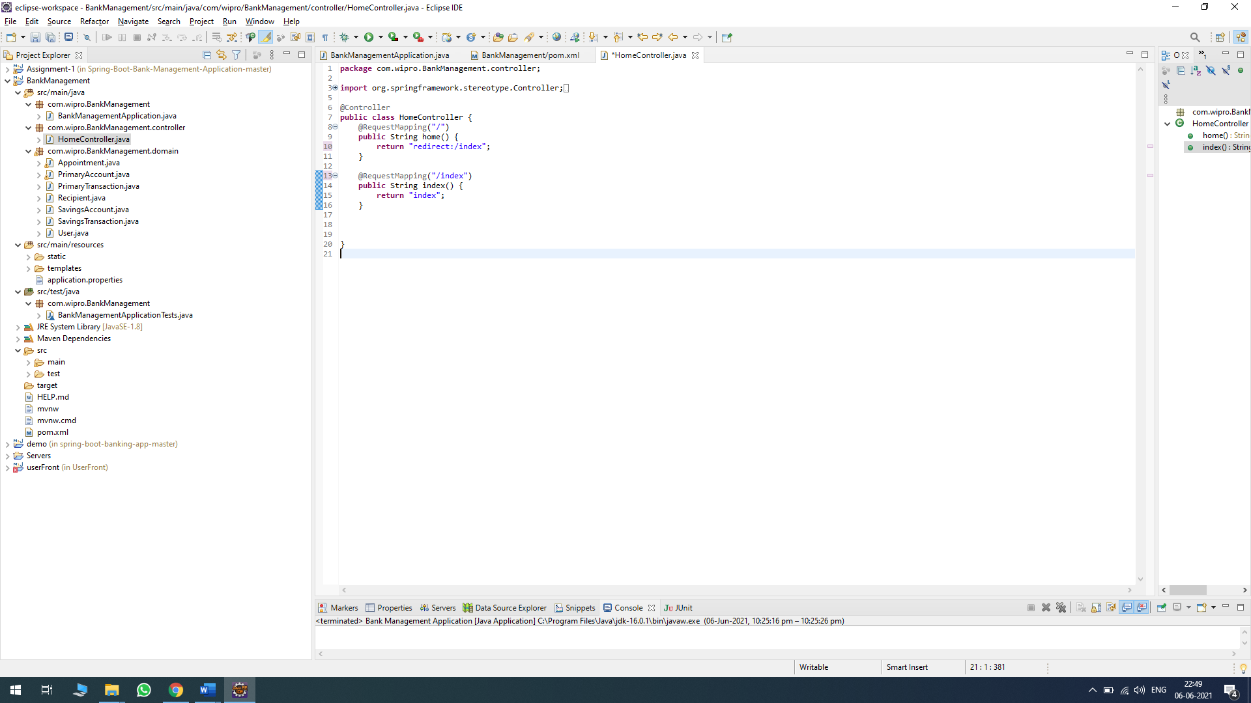

The first login page of the project

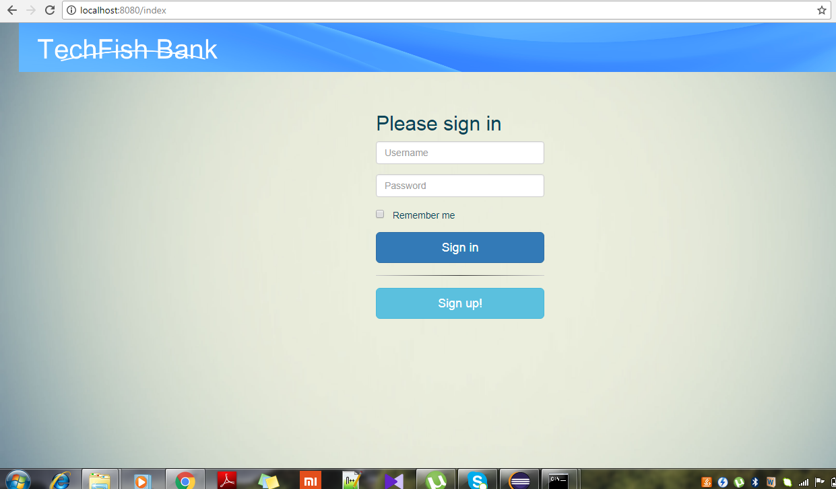

User class in the project is used to store the details of the customer in the Lists

Such as userID, username, password, firstName, LastName, email, phone

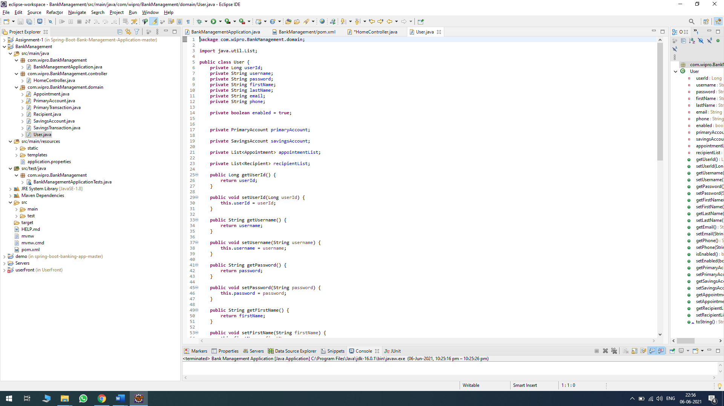

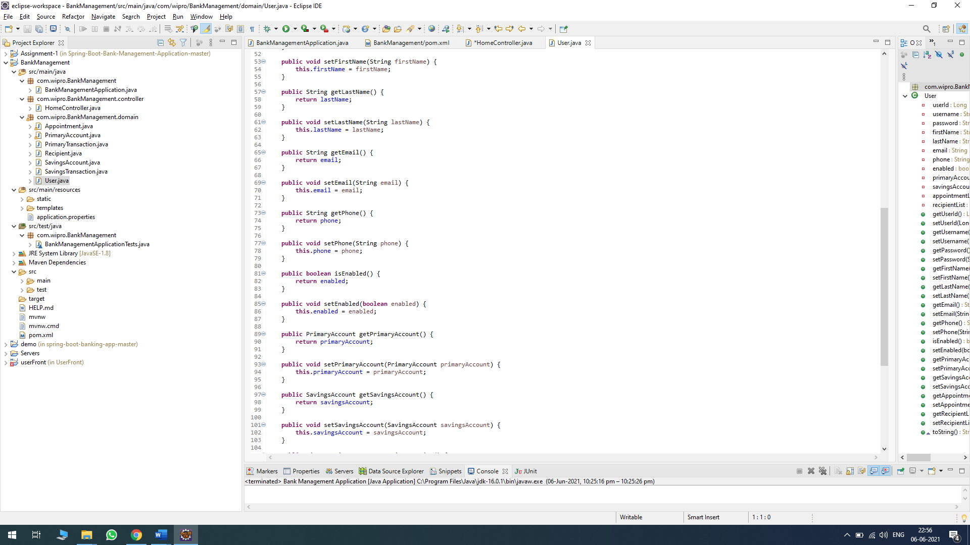

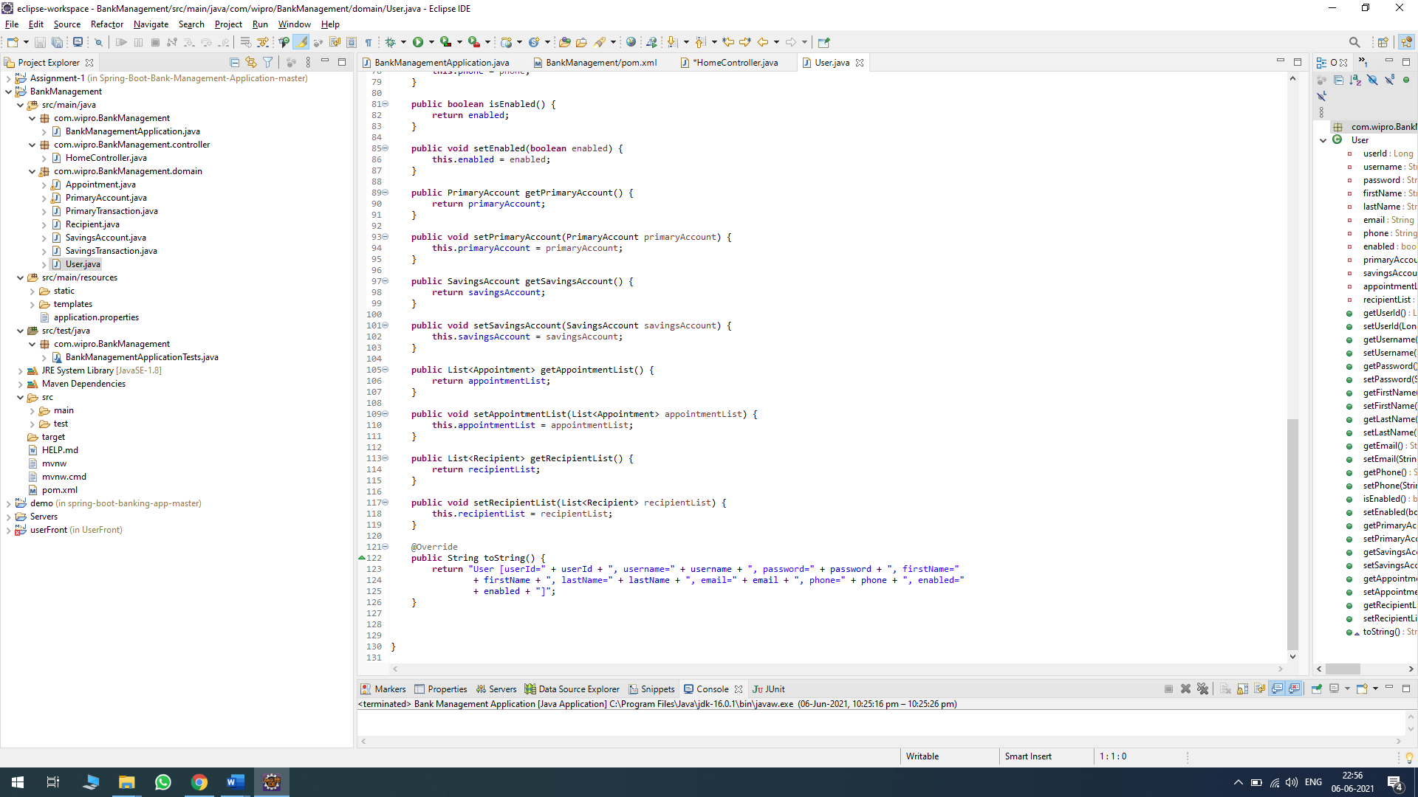

Various classes SavingsAccount, SvaingsTransaction, Reciepent are used to perform the transaction among the accounts.

BankManagementApplicationTest is the testing class which is used to run the Junit testing using @test Annotation

